RFID/NFC BASED ATTENDANCE SYSTEM

A PRODUCT DEVELOPMENT REPORT

Submitted to

SAVEETHA INSTITUTE OF MEDICAL AND TECHNICAL SCIENCES
In partial fulfillment of the award of the degree of

BACHELOR OF ENGINEERING
By

Bharathwaj K S 192124033
Venkata Gowtham Naik N 192111137



SIMATS ENGINEERING
SAVEETHA INSTITUTE OF MEDICAL AND TECHNICAL SCIENCES,
CHENNAI – 602 105



SIMATS ENGINEERING

SAVEETHA INSTITUTE OF MEDICAL ANDTECHNICAL SCIENCES

CHENNAI – 602105

BONAFIDE CERTIFICATE
Certified that this product development report “RFID/NFC Attendance System” is the Bonafide work of “192124033 Bharathwaj K S and 192111137 Venkata Gowtham Naik N” who’s Carried out the product development work under my supervision

HEAD OF THE DEPARTMENT
Professor
Department of Computer Science and Engineering
SIMATS Engineering
Saveetha Institute of Medical and Technical Sciences
Chennai – 602105

SUPERVISOR
Professor
Department of Computer Science and Engineering
SIMATS Engineering
Saveetha Institute of Medical and Technical Sciences
Chennai - 602105

INTERNAL EXAMINER EXTERNAL EXAMINER

DECLARATION BY THE CANDIDATE

I declare that the project entitled “RFID/NFC BASED ATTENDANCE SYSTEM” submitted by me for SPIC713 Product Design & Development for AI and Full Stack Development is the work carried out by me during the period from ------------------------- under the guidance of Dr.S.Kalaiarasi and has been completed successfully.

Bharathwaj K S
Signature of the Candidate
(name)

INDEX

S.NO | TOPICS | PAGE NO
1 | INTRODUCTION | 6
2 | DESIGN PROCESS | 7
3 | SYSTEM ARCHITECTURE | 8
4 | DESIGN DETAILS | 9
5 | DEPLOYMENT AND MAINTENANCE DEPLOYMENT PLAN | 10
6 | APPENDICES GLOSSARY | 11
7 | SAMPLE IMAGES ……. | 12
8 | CONCLUSION AND FUTURE SCOPE | 13
9 | REFERENCES | 14
10 | PATENT PUBLISHED PROOF

LIST OF TABLES

TABLE NO | TITLE | PAGE NO
3.1 | Comparison of Alternative Products | 8
3.2

LIST OF FIGURES

FIGURE NO | TITLE | PAGE NO
1.1 | Hand drawn physical illustration of the product with dimension | 9
1.2 | Side 3D view | 10
1.3 | Front 3D view | 10
1.4 | Top View | 11
1.5 | Product Front View | 12
1.6 | Product Back View | 12

LIST OF SYMBOLS AND ABBREVIATIONS

RFID | Radio Frequency Identification
NFC | Near-field communication
ISO | International Organization for Standardization
IEEE | Institute of Electrical and Electronics Engineers

RFID/NFC Based Attendance System

Executive Summary:
The NFC/RFID Based Attendance System is designed to modernize the attendance process by leveraging cost-effective NFC and RFID technology. The system updates data in real time and integrates with Google Sheets, allowing students and administrators easy access to attendance records. This solution addresses the market need for a simple, affordable, and efficient attendance system. It stands out by offering real-time updates, ease of access, and lower costs compared to conventional systems that require expensive hardware or complex software.

Introduction:
- Problem-Statement:
Current attendance systems are often expensive, require separate database infrastructure, and lack user-friendly accessibility, making it hard for institutions to monitor attendance effectively in real time.
- Purpose:
The main objective of this project is to develop an NFC/RFID-based system that simplifies the attendance process, making it cost-effective and easy to access via real-time Google Sheets integration.
- Scope:
This project focuses on using NFC/RFID technology to create a real-time attendance system that can be implemented in educational institutions. The system has some constraints, such as limited scalability for large organizations and reliance on an internet connection for real-time updates.

Bharathwaj.K.S Venkata Gowtham Naik N Kalaiarasi.S

GPCU
- Gap Analysis:
Market Gap or Lacune:
The current market lacks a cost-effective, real-time attendance system that is simple to implement and maintain. Many existing systems are either expensive or require specialized software to access data. There is a growing demand for a more affordable solution that leverages existing technologies like NFC and RFID. Example: "While biometric systems exist, they are often expensive and not easily accessible to all institutions. Manual attendance tracking systems, on the other hand, are prone to errors and are time-consuming."

Product Description:
- Product Overview:
The NFC/RFID Based Attendance System offers a seamless and affordable method to track attendance in real time. By scanning NFC/RFID tags, students can mark their attendance, and the data is updated instantly in Google Sheets. This approach eliminates the need for manual attendance tracking and reduces administrative overheads. Key features include real-time data updates, cost-effective NFC/RFID tags, and easy accessibility through Google Sheets.

Bharathwaj.K.S Venkata Gowtham Naik N Kalaiarasi.S

Comparison of Alternative Products: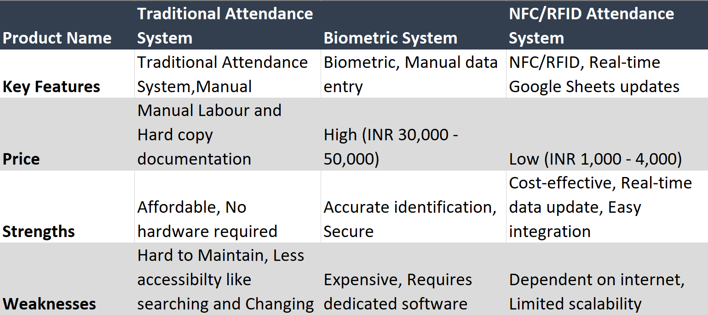

Table 1: Comparison table

Uniqueness of Your Product:
- How Your Product is Unique:
Our product stands out by offering real-time updates through Google Sheets at a lower cost compared to traditional systems. It is designed to be simple and cost-effective, using NFC/RFID tags that are inexpensive and widely available. Unlike biometric systems that require expensive hardware and complex software, our solution can be easily implemented in smaller educational institutions or organizations.

Design and Engineering Standards:
- Relevant Standards Applied:
  - ISO 9001: Quality management systems for consistent performance.
  - IEEE 802: Standards for networking technology and real-time data transfer.
  - ISO 27000: Information security management to ensure data privacy during real-time updates.
Bharathwaj.K.S Venkata Gowtham Naik N Kalaiarasi.S

2D Design:
- Technical Sketches and Diagrams:
The system consists of NFC/RFID readers placed at entry points. Students scan their NFC tags, and the system immediately updates attendance records in Google Sheets. The diagram includes labeled components like the NFC reader, Google Sheets interface, and power supply.
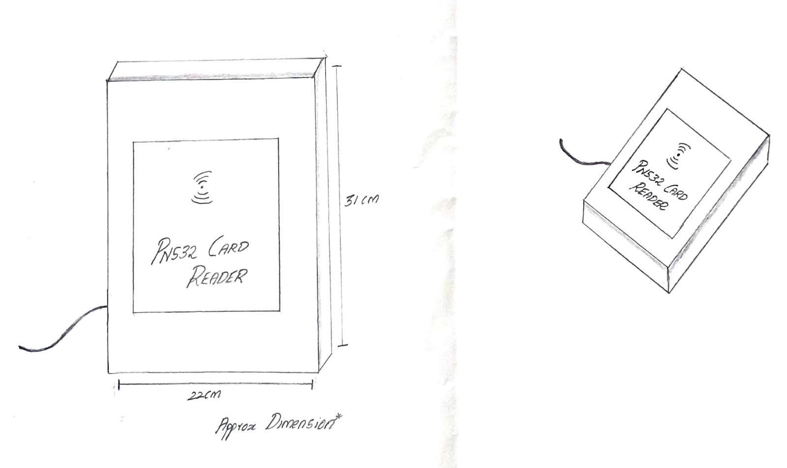
FRONT VIEW TOP VIEW

Fig 1: Hand drawn physical illustration of the product with dimension

Bharathwaj.K.S Venkata Gowtham Naik N Kalaiarasi.S

3D Design:
- 3D Model of the Product:
The product includes a small NFC/RFID reader box, with a sleek design to fit on a desk or mounted on walls. A CAD model demonstrates the layout of the reader, antenna, and power supply components.
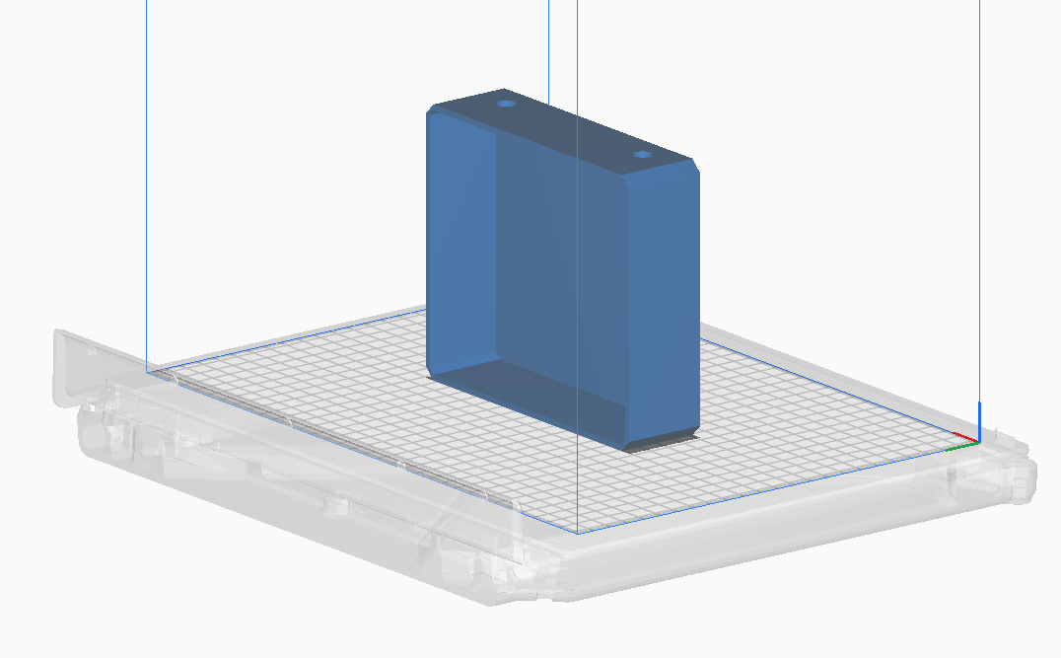
Fig 2 Side 3D view

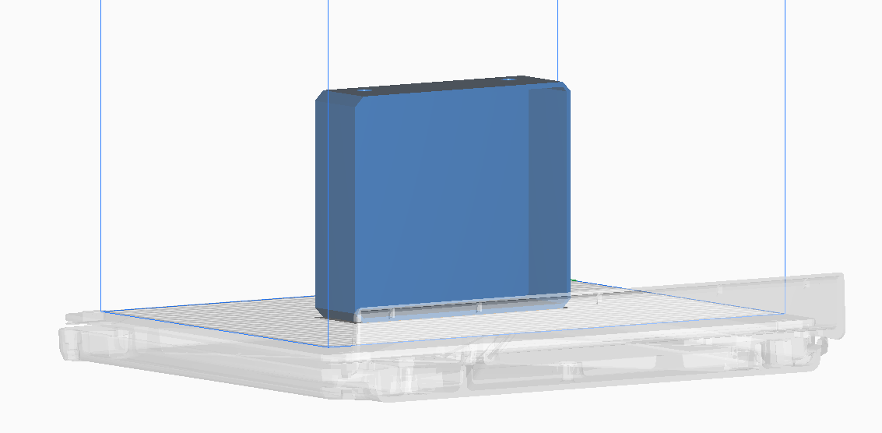
Fig 3 Front 3D view

Bharathwaj.K.S Venkata Gowtham Naik N Kalaiarasi.S
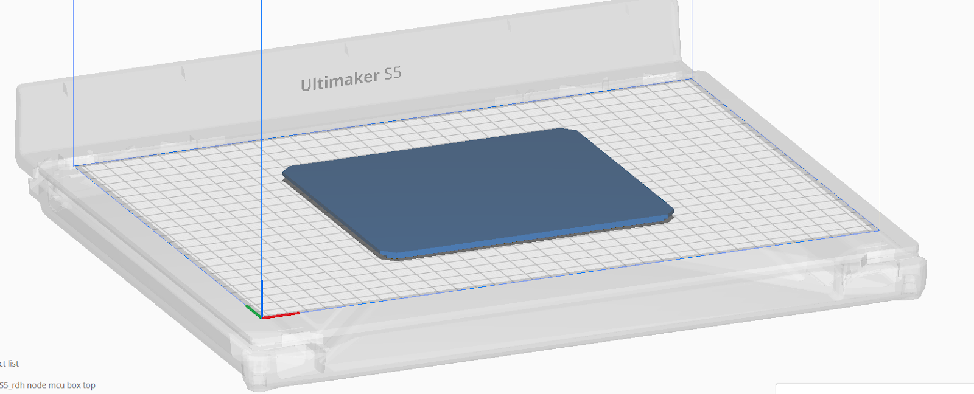
Fig 4 Top view (lid)

Functional Prototype:
- Prototype Description:
The prototype was built using an NFC/RFID reader module connected to a microcontroller (NodeMCU) that communicates with Google Sheets through a Wi-Fi connection. Materials include NFC tags, a PN532 reader, and a 3.3V short buzzer for successful scan indication.
- Testing and Validation:
The prototype was tested in a small-scale setting, where real-time attendance updates were successfully recorded in Google Sheets. Adjustments were made to improve Wi-Fi connectivity for faster data transfer.

Bharathwaj.K.S Venkata Gowtham Naik N Kalaiarasi.S
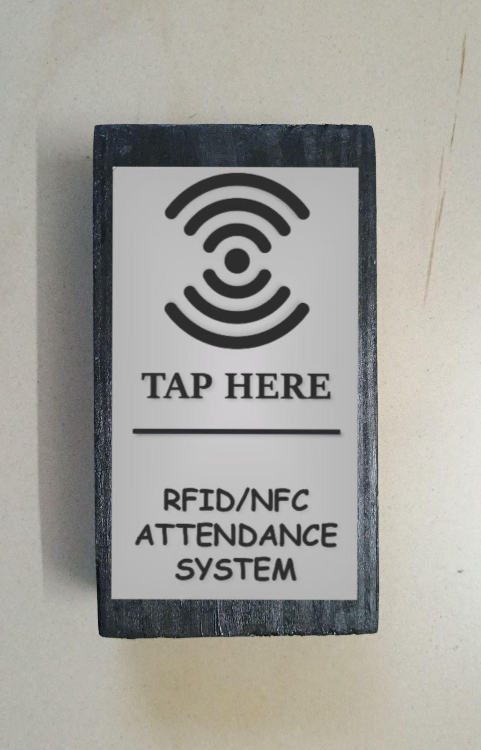 | 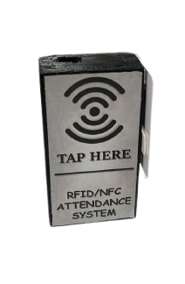

Fig 5 Front view Fig 6 Top view

Conclusion and Future Work:
- Summary of Key Points:
The NFC/RFID-based system fills the gap in affordable, real-time attendance solutions. It was tested successfully in a small-scale environment and provides a cost-effective, user-friendly solution for attendance tracking.

Bharathwaj.K.S Venkata Gowtham Naik N Kalaiarasi.S

- Challenges Faced:
Initial issues with Wi-Fi connectivity and delays in real-time data updates were overcome by optimizing the microcontroller’s code and improving network reliability.

- Future Improvements:
In future versions, we plan to add a messaging alert system that sends notifications to students about their attendance status and integrates with student management systems.

References:

- S. Shukla, M. Sharma, and A. Gupta, “RFID-based attendance system: Implementation and challenges,” International Journal of Computer Applications, vol. 175, no. 12, pp. 15–19, 2022. Available: https://doi.org/10.1016/j.seja.2024.100077
- M. Reddy, P. Kumar, and V. Singh, “Comparative analysis of RFID and NFC technologies in attendance management systems,” Journal of Engineering and Applied Sciences, vol. 14, no. 3, pp. 276–280, 2021. Available: http://dx.doi.org/10.1201/9781003527251-1
- D. Chen and Y. Zhang, “Design and implementation of an NFC-based smart attendance system,” IEEE Transactions on Industrial Informatics, vol. 17, no. 4, pp. 2305–2312, Apr. 2021. Available: https://doi.org/10.1109/TII.2021.3138206
- P. Jain and R. Singh, “NFC in smart systems: A case study in attendance management,” Advances in Science, Technology, and Engineering Systems Journal, vol. 6, no. 2, pp. 95–100, 2020. Available: http://dx.doi.org/10.1051/bioconf/20248601098
- A. Kumar and S. Sharma, “Integrating IoT and RFID for scalable attendance solutions,” IEEE Internet of Things Journal, vol. 8, no. 3, pp. 1764–1772, Feb. 2021. Available: http://dx.doi.org/10.11591/ijeecs.v23.i3.pp1432-1439

Bharathwaj.K.S Venkata Gowtham Naik N Kalaiarasi.S

